Name __________________________
Animal Adaptations, Source: Wildlife Informer
What is adaptation? An adaptation is a special skill that helps organisms to survive in their environments. Adaptations could be physical, physiological, or behavioral. All living things (including humans) on this planet have adaptations. Adaptations are influenced by environmental factors, including climate and food availability. Animals have needs like food, water, shelter, and breeding. To meet those needs, animals adapt to their environment.

1. Physical adaption examples:
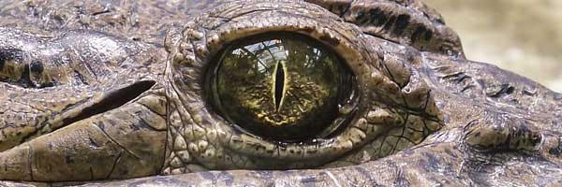
A body covering adaptation refers to when the skin or covering of the animal has changed and adapted over time to better suit survival in the animal’s environment. Some examples include scales, webbed feet, sharp claws, wings, hooves, striped or spotted fur, or feathers.

2. Behavioral adaptation examples:
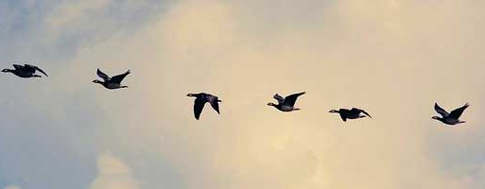
Behavioral adaptations in animals refers to the actions or behavior of an animal changing over time to increase its chances of survival. Some examples include migration, instincts, hibernation, nocturnal, and diurnal.

3. Physiological adaptation examples:

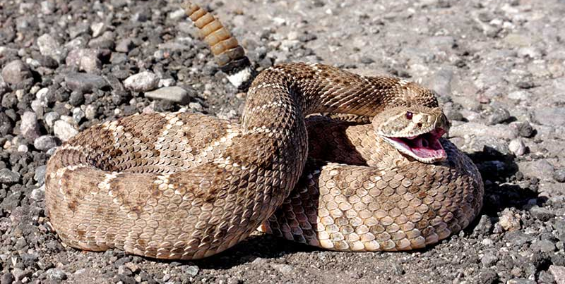
Physiological adaptations are metabolic changes in an animal that help them to survive. For example, a snake’s ability to produce venom, mammal’s ability to maintain constant body temperature, the release of toxins or poisons, releasing antifreeze proteins to avoid freezing in cold environments, etc.
Florida Animals – Explore the photographs below and learn about one of the animal’s traits or skills. How does this adaptation help the animal survive?
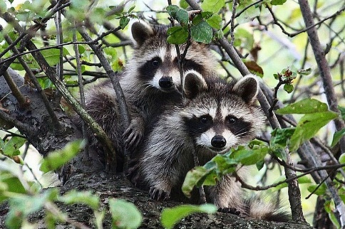  Raccoons are nocturnal. | 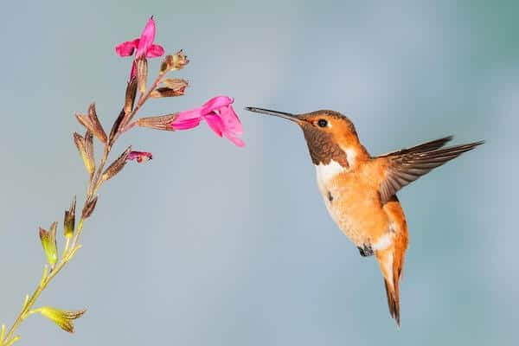  Hummingbirds have long beaks. | 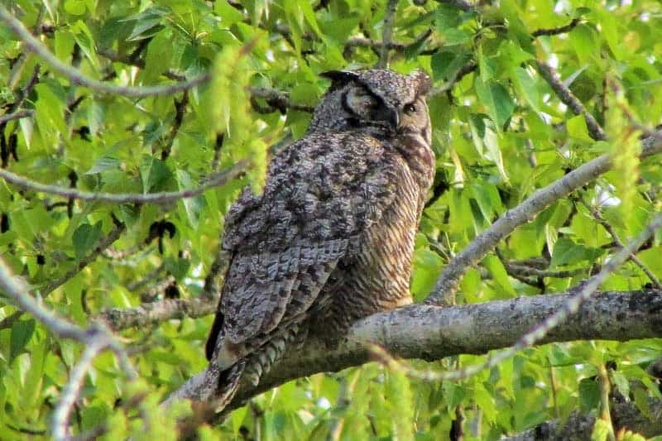  Owls can rotate their necks 270 degrees.
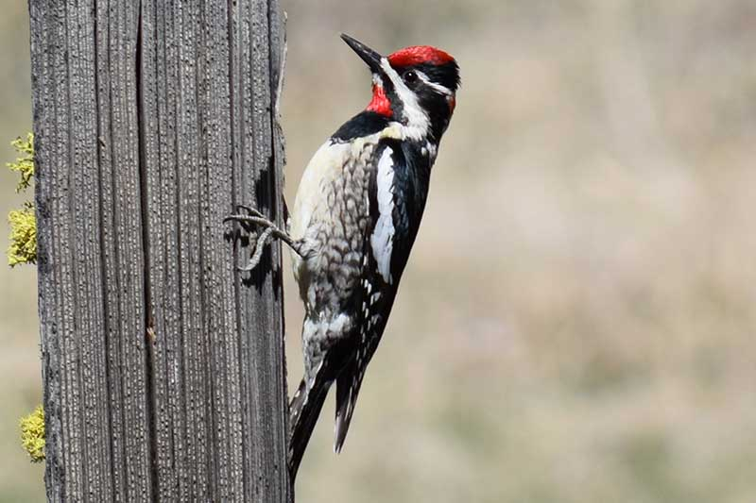  Woodpeckers have zygodactyl (two toes pointing forward and two backward). | 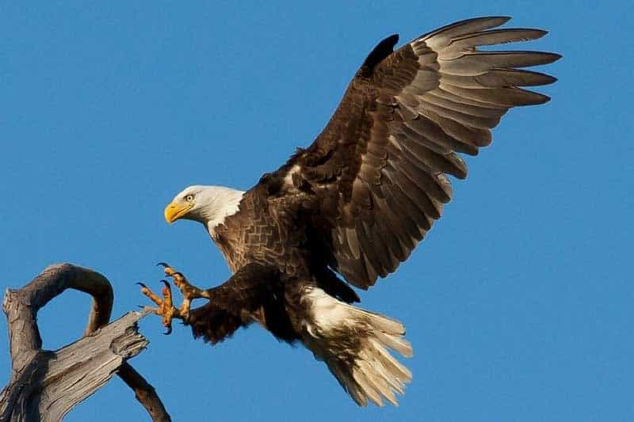  Eagles have powerful talons and sharp beaks. | 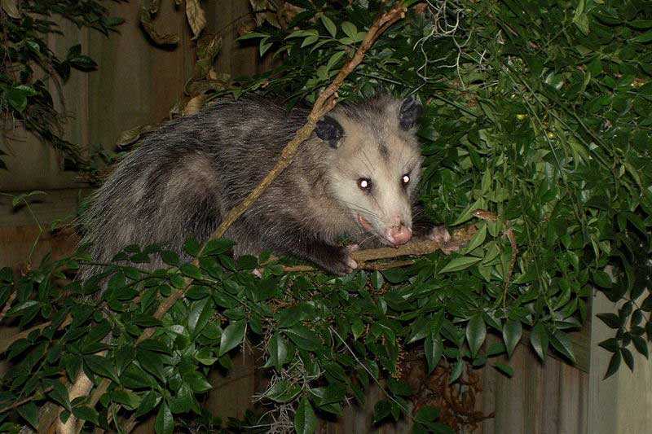  Opossums have opposable thumbs and prehnsile (capable of grasping) tails.
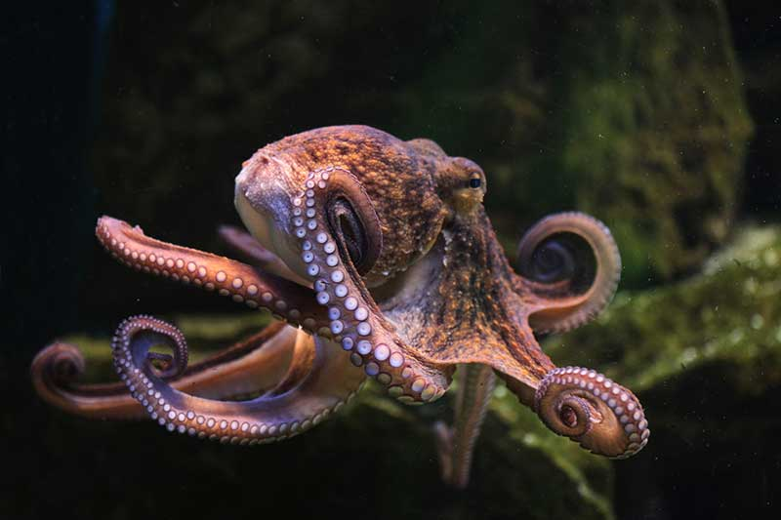  Octopuses change the color and texture of their skin. | 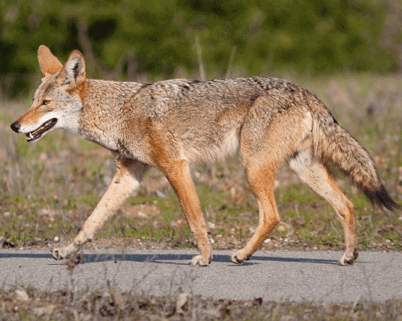  Coyotes have amazing speed (up to 40 miles per hour). | 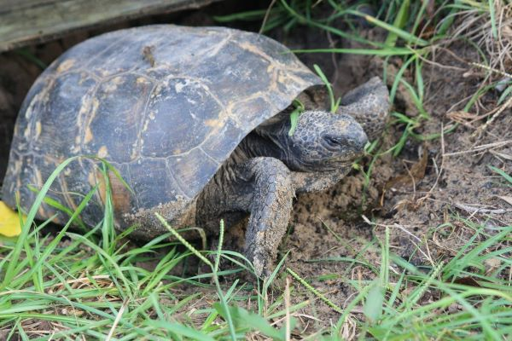  Gopher tortoises burrow under the sand.

